Quy Pham
ECE 201 Lab
Lab 2: Plotting in MATLAB
Spring 2008
Lab 2: Plotting in MATLAB

%% Question 1
clear all;
clc;

%% Question 2. Epitrochoid curve. Mercury's orbit
%
t = 0:pi/360:22*2*pi/3;
x = 93*cos(t)+36*cos(4.15*t);
y = 93*sin(t)+36*sin(4.15*t);
figure(1);
plot(x,y);
xlabel('x(t)');
ylabel('y(t)');
title('Plot of Mercury''s orbit (as seen from the Earth');
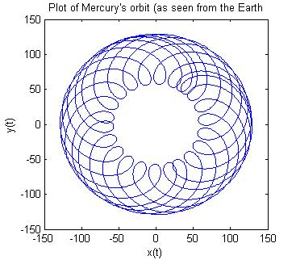

%% Question 3: use axis to zoom in
%
axis([-50 0 -150 -100]);

%% Question 4:
%
t = 0:0.001:5;
f = 50;
% a.
%
y = 30*sin(2*pi*f*t + pi/4);
figure(2);
plot(t,y);
xlabel('Time t');
ylabel('y(t)');
title('y(t) = 30*sin(2*pi*f*t + pi/4)');

%% b.
%
%t = 0:0.001:5;
%f = 50;
%y = 30*sin(2*pi*f*t + pi/4);
figure(3);
plot(t,y);
axis([0 1 -30 30]);
xlabel('Time t');
ylabel('y(t)');
title('y(t) = 30*sin(2*pi*f*t + pi/4)');
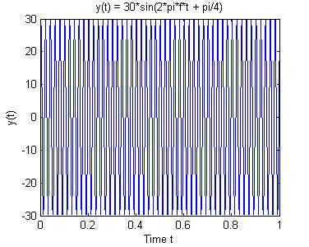
%% c.
%
y = 30*sin(2*pi*f*t + pi/4) .* exp(-4*t);

%% d.
%
%t = 0:0.001:5;
%f = 50;
y = 30*sin(2*pi*f*t + pi/4) .* exp(-4*t);
figure(4);
plot(t,y);
axis([0 1 -30 30]);
xlabel('Time t');
ylabel('y(t)');
title('y(t) = 30*sin(2*pi*f*t + pi/4) .* exp(-4*t)');
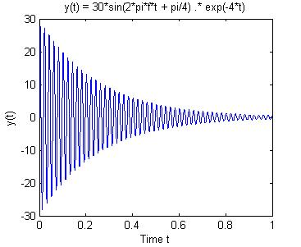
%% e.
%
y = 30*sin(2*pi*f*t + pi/4);
sound(y); % the sound last long and has the same amplitute
%%
y = y .* exp(-4*t);
sound(y); % amplitute decreases rapidly make the sound sounds really short

%% Question 5: subplot
%
figure(5);
% epitrochoid (q2) in middle plot
%
t = 0:pi/360:22*2*pi/3;
x = 93*cos(t)+36*cos(4.15*t);
y = 93*sin(t)+36*sin(4.15*t);
subplot(1,3,2);
plot(x,y);
xlabel('x(t)');
ylabel('y(t)');
title('Epitrochoid');
% exponential decay function q4c on the left plot
%
t = 0:0.001:5;
f = 50;
y = 30*sin(2*pi*f*t + pi/4) .* exp(-4*t);
subplot(1,3,1);
plot(t,y);
xlabel('Time t');
ylabel('y(t)');
title('Exp. decay func.');
%axis([0 1 -30 30]);
% sinusoid 4a in right plot
%
%t = 0:0.001:5;
%f = 50;
y = 30*sin(2*pi*f*t + pi/4);
subplot(1,3,3);
plot(t,y);
xlabel('Time t');
ylabel('y(t)');
title('Sinusoid');
axis([0 1 -30 30]);
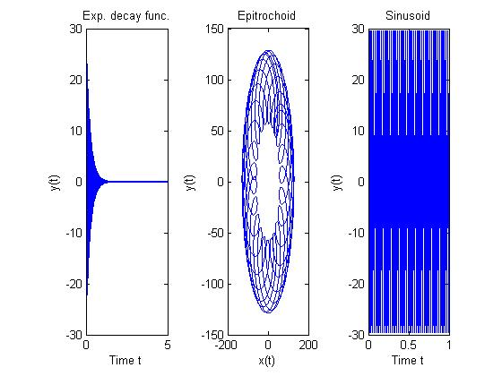
%% Question 6:
% a.
figure(6);
t = 0:0.001:1;
% b.
y = 20*sin(2*pi*50*t - pi/2);
subplot(2,2,1); % plot at upper left
plot(t,y,'-go'); % solid green with denote points with 'o'
ylabel('y(t)');
xlabel('Time t');
title('y = 20*sin(2*pi*50*t - pi/2)');
% c.
y = 10*sin(300*t + pi/4);
subplot(2,2,2); % plot at upper right
plot(t,y,'--rx');
ylabel('y(t)');
xlabel('Time t');
title('y = 10*sin(300*t + pi/4)');
% d.
y = 100*sin(100*t + pi/4);
subplot(2,2,4); % plot at lower right
plot(t,y,':k*');
ylabel('y(t)');
xlabel('Time t');
title('y = 100*sin(100*t + pi/4)');
% e.
y = 10*sin(2*pi*10*t + 3*pi/2);
subplot(2,2,3); % plot at lower right
plot(t,y,'-b.');
ylabel('y(t)');
xlabel('Time t');
title('y = 10*sin(2*pi*10*t + 3*pi/2)');
